ASCII-Value_Program

**package** conditionalStatments1;

**public** **class** ASCIIValueProgram

{

**public** **static** **void** main(String[] args)

{

//WAP to print ASCII number/value

//chars on keyboard-rollNumber allocate

// rollNumber-->ASCII

//case-I

// char x = 'A';

// System.out.println("Char is- "+x);

//

// int y= x;

// System.out.println("ASCII value is- "+y);

//case-II

**int** x = 48;

System.***out***.println("ASCII value- "+x);

// 65-->ASCII-->char ???

**char** y = (**char**)x; //casting syntax

System.***out***.println("char is- "+y);

//------------------------

**int** a = 9; //number

**char** b ='9'; //char

String c = "9"; //word--> a

}

}

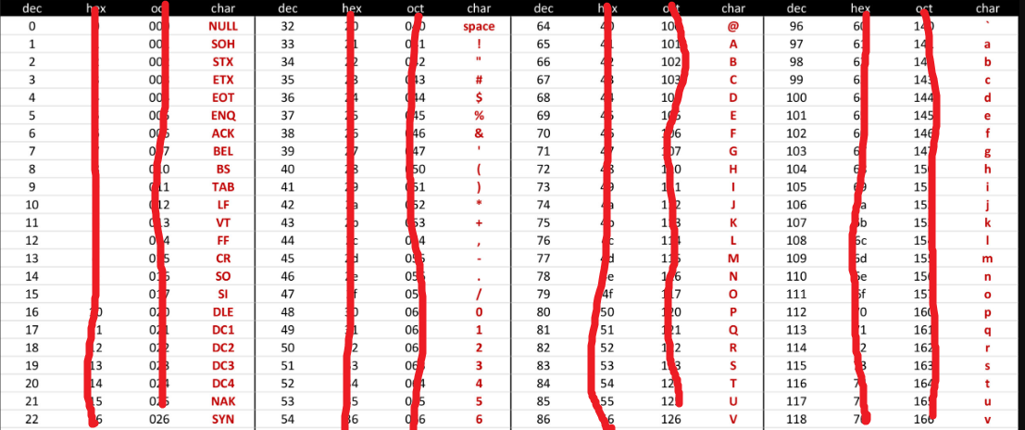

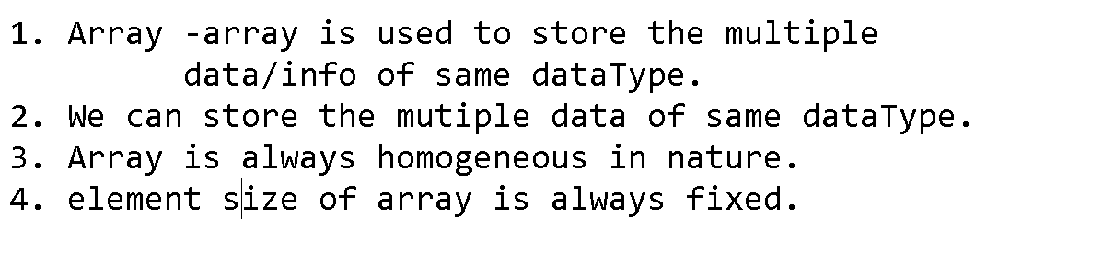

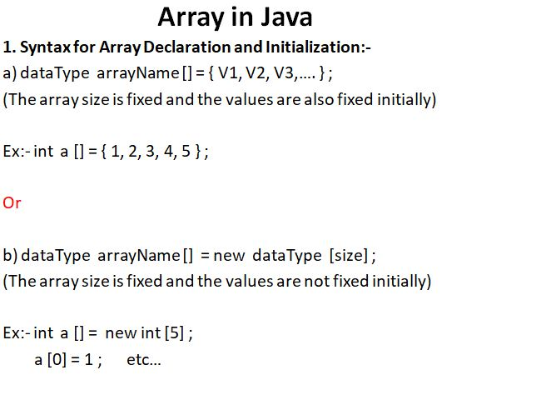

Array_Program

**package** conditionalStatments1;

**public** **class** ArrayConcept1

{

**public** **static** **void** main(String[] args)

{

//add of 2 numbers

// int a = 100;

// int b = 200;

// int c = a + b;

// System.out.println(c);

//add of 5 numbers

**int** a = 10;

**int** b = 20;

**int** c = 30;

**int** d = 40;

**int** e = 50;

**int** f = a+b+c+d+e;

System.***out***.println(f);

//repeated code

//more variable -more memory

//code maintain-diffucult

//code lengthy

//solution

//array concept

**int** x [] = {10,20,30,40,50};

//not possible

// int y [] = {10, 10.77, 'A', "RAHUL"};

//always use same-dataType data only

//char array

**char** y [] = {'A', 'B', 'C'};

}

}

